Link to App: https://github.com/Vi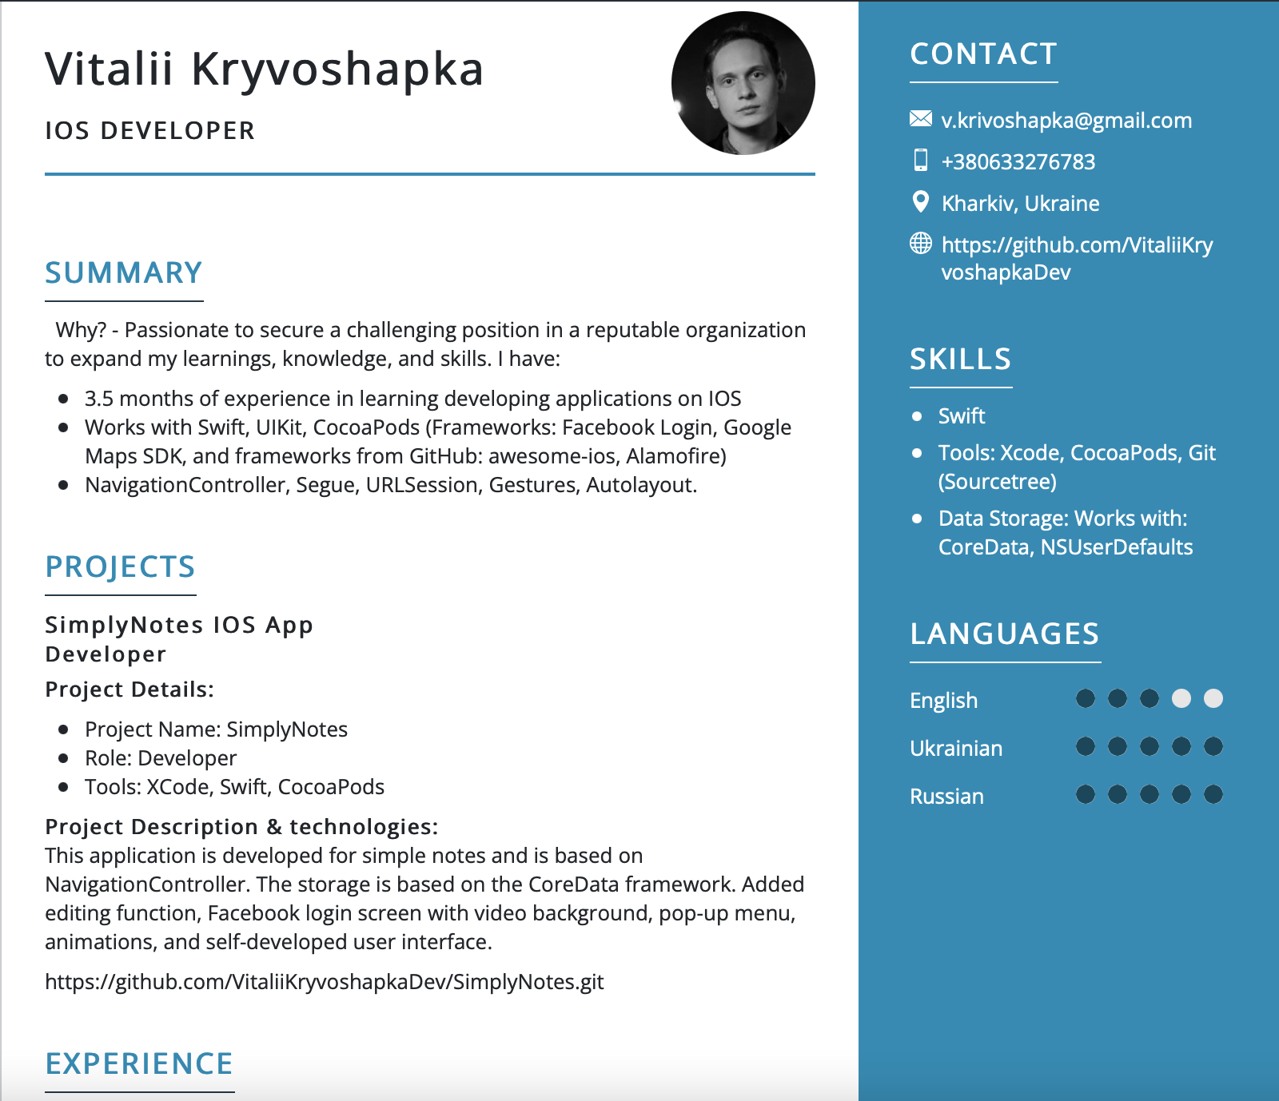taliiKryvoshapkaDev/SimplyNotes.git